

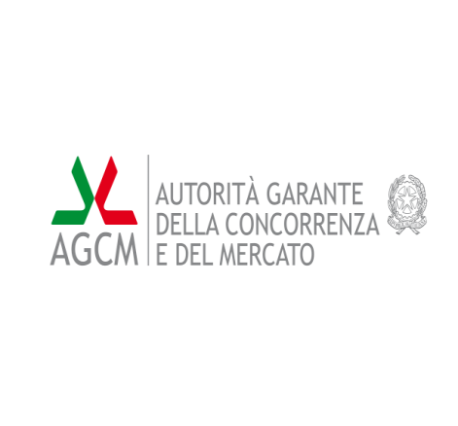  Ministero dello Sviluppo Economico

Italian Presidency Event

International Conference

**“EU Cooperation for enforcement of consumer legislation”**

**7-8 July 2014**

**Venue:** Autorità Garante della Concorrenza e del Mercato – Auditorium –

**Via C. Monteverdi, 35 - ROMA**

The Italian Competition Authority has the great pleasure of inviting you to the Italian Presidency Event: *“EU Cooperation for enforcement of consumer legislation”.*

The International Conference is hosted by the Italian Competition Authority, the Ministry of Economic Development in cooperation with the European Commission.

The two half-day Event (afternoon on the 7th and morning on the 8th July) is addressed to delegates from European Commission, EU and EFTA Member States, National Consumer Protection Authorities, European consumer organizations, professionals representing competent State institutions, members of consumer and business associations, scholars. The event will be an opportunity to discuss the development of the consumers rights and the EU regulation, its perspectives and the challenges and opportunities for both businesses and consumers.

The afternoon session of the Day 1 (7th July) will include four topics:

* Opening remarks
* EU Commission’s Keynote speech
* Member States’ national perspectives
* A roundtable on possibilities and opportunities arising from the Consumer Protection Cooperation Regulation

The morning session of the Day 2 (8th July) will be organized in two roundtables with the following themes:

* Cooperation on e-commerce issues
* Consumer legislation and e- commerce challenges

An Italian/English and English/Italian translation service will be provided.

Please find enclosed the Conference programme.Full information about the event, travelling and accommodation details and travel cost reimbursement and practical information, as well as the registration form to be downloaded, will be available starting on ***Friday 23****th* ***May 2014***, on the webpage <http://www.agcm.it/it2014eu-reg.html> *.* Registration will open on ***23****th* ***May 2014*.** Please fill the form and send it to: [it2014eu@agcm.it](mailto:it2014eu@agcm.it). We kindly invite you to register as soon as possible and no later than **13**th **June 2014**, to allow a smooth organization of the event.

For any queries, you can contact us at the e-mail address: [it2014eu@agcm.it](mailto:it2014eu@agcm.it).

We look forward to meeting you in Rome.

Yours sincerely,

**Giovanni Pitruzzella**

Chairman

The Italian Competition Authority

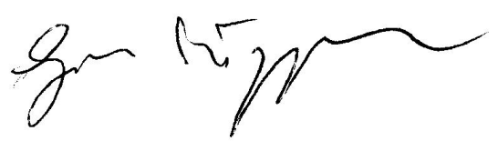

**NB: Following the afternoon day 1 event, a guided walk on the Aventine hillhas been arranged for the delegates, starting at 19:00. A buffet dinner will follow at 20.30.**