PORTUGAL
The digital market and its problems
The market context
The digital market in Portugal has been truly boosting in terms of another market. The cutting-edge technology and the expansion of mobile communications - in particular "smartphones" - has greatly contributed to the rise of electronic commerce. In fact, between 2012 and 2014, in Portugal we have seen an increase of about 40% of online purchases (in a country that still privileges the personal relationship between the retailer and the consumer). However, it is important to note that this increase occurs primarily in domestic trade, i.e., most online purchases only relate to Portuguese companies. There is also some shyness in terms of conquering the domestic market by foreign companies (many companies do not sell products or provide services in Portugal or the shipping costs are too high compared to the market value of the product).
At the same time, purchases made ​​through online platforms, including social networks such as Facebook, have been increasing, recently. It is a form of commerce that deserves to be closely monitored, since not only it is often difficult to distinguish one from a private company, but also some companies use these mechanisms, in order to, by stating that the products are more affordable, they inform consumers that their choice prevents them from taking advantage of a set of rights, namely, legal guarantees or rules regarding return and cooling-off period.
Another note concerns the proliferation of new trading platforms of second-hand goods. The economic crisis and the e-commerce have favored the use of these platforms to sell products in a C2C relation. As is the previous case, since it is difficult for a consumer to distinguish between a private person and a retailer (sometimes there is no information about the trader’s identity) it is important to maintain a closely monitoring on this new form of marketing and ensure that consumers' rights are not violated.
Finally, it still deserves to be highlighted the fact that the mobile market is clearly growing, highlighting the growth of mobile payment services and applications, without there being, however, sufficient safeguards for consumers. Everything is possible through an application, but, though being possible, we still don’t know completely, its risks and contractual issues.
General problems
During this year, until September, we have received more than 4103 complaints regarding online purchase as we can see in the following graphic:

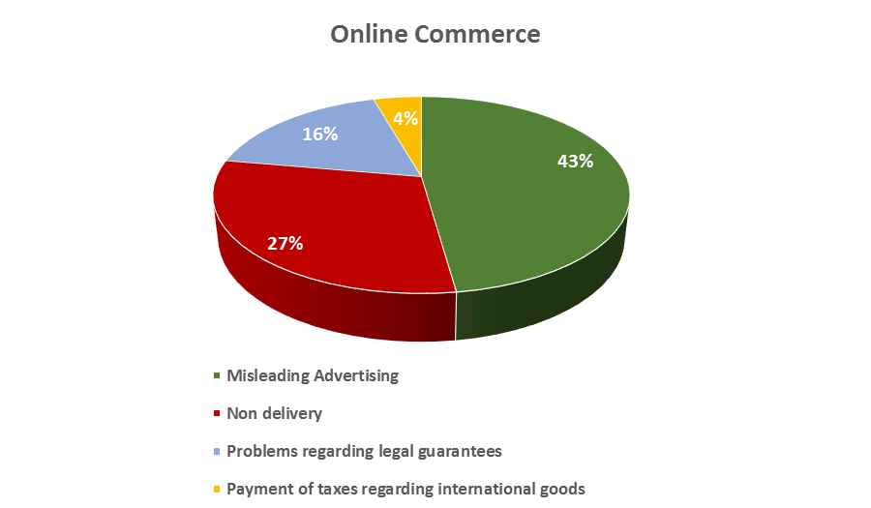
Notwithstanding the problems previously identified, we can be divide them into eight categories: accessibility, reliability, information, performance, enforcement, privacy, security and conflict resolution.
Accessibility
Given the expansion of the electronic commerce, it is certain that one of its essential elements is connected with the internet. And at this point, if urban populations, already enjoy (mostly) access to an internet service quality, the same cannot be said of the rural population or even the older population. Factors such as digital illiteracy, vulnerability of certain types of consumers and the fact that the universal service only includes a very small velocity and, this velocity is, even, no longer marketable (56Kps), harms consumers in regards to the digital market.
We mustn’t forget that the portuguese digital revolution of the last years, has implicated that most of the public actions that must be undertake by citizens (presentation of the declaration of tax payment, legal documents requests, payments, etc) are already mandatory done in a digital environment and the mechanisms previously used by consumers for these functions (post offices, for example) tend to decrease or even disappear in the near future. Also, in Portugal there are high levels of digital exclusion, especially in the aging population, in rural or sparsely populated, which requires further monitoring and the adoption of rules in order to protect them. Consumers, therefore, cannot benefit from a true digital market. The risk of exclusion for vulnerable consumers is total.
Reliability
Trust is an essential element in the contractual relations between professionals and consumers. However, it is very common in Portugal the identification of fraud schemes related to websites whose contents are completely unreliable. Notwithstanding the constant complaints of DECO to the supervisory bodies, the fact is that many consumers are still unaware of the nature of some websites which hinders trade relations.
Information
Over the last few years, DECO has conducted several studies regarding companies whose commercial activity occurs especially in an online environment. In the latter study, prior to the entry into force of the new Consumer Rights Directive, we found that many websites did not had information regarding:
    - The identity of the seller;
    - The characteristics of the good and service;
    - Price (many websites do not have the inclusion on the price of its taxes and additional charges);
    - Methods of payment and delivery of goods;
    - Cooling-off period, contract termination and reimbursement.
Meanwhile, DECO, also conducted, in 2014, a comparative analysis of several services sold online, such as telecommunications, air transport / travel and cloud computing. In all of them we identified:
    - Website’s lack of transparency;
    - Several unfair contract terms;
    - Difficulty in applying the law, thus, non-compliance with the Rome I Regulation;
    - Unfair commercial practices;
    - Misleading Advertising.
Performance
Following the studies conducted by DECO we conclude that, often, companies do not respect the deadlines and the money refund policy. Consumers are effectively harmed because they are, not only deprived of the item ordered, but also of the amount already paid.

Enforcement
It's easy to create a website and it is even easier to shut it down. This is one of the assumptions that must be taken into account when analyzing the development of the digital market. Indeed, enforcement remains one of the problems with which consumers are struggling more. In Portugal, there is a multiplicity of supervisory bodies, and they often compete in the same oversight of these issues, especially with regard to the digital market. For example, the infrastructure, networking and the e-commerce in general, all are supervised by one entity, but the actual contractual relationship between the consumer and the retailer is monitored by another entity. The same applies to the Consumer Rights Directive and the rules on misleading practices, both of which are overseen by different entities.
Notwithstanding the multiplicity of enforcers, it should also be added the fact that there is no continuous monitoring of some companies that operate exclusively online and that have a higher level of complaints.
Delivery of goods (international digital market)
This point is also of paramount importance, especially when dealing with international trade, from countries like Japan, China, Brazil and the United States of America (common suppliers in Portugal). However, the administrative and fiscal barriers often prevent consumers to benefit from a true digital market. In fact, many consumers complain about the fact when they purchase goods from these countries and, sometimes, they are retained in the Portuguese custom boarder without any justification or even without any information to the consumer. Also, it is difficult for the consumer to real track his purchases. Please note that, in Portugal, these costs are only paid when the order value, if we are talking about a company, is more than 22 euros. The randomness and lack of transparency off the goods’ checking or even without any consumer control is clearly an obstacle to the development of this market in Portugal.
Privacy
Among the key sources of privacy problems we identified, in Portugal, a lack of understanding with regard to the length of ownership of their information and the ways in which providers can subsequently use their information. For example, detriment can arise through the active provision of data (e.g. bank details, postal addresses, social networks, cloud computing services), namely, how this information may be used, or for how long it may be stored or remain on the Internet. We also notice some problems when consumers are not aware of how the information they have put on the internet may be collected or tracked by others (e.g. for marketing and / or behavioral advertising purposes).
Security
This one is an important topic, namely the problems that often arise, including email scams, spam mail and texts, identify theft, viruses, loss of information and even the security of online possessions (e.g. in online gaming). Detriment may take the form of financial consequences (such as costs Incurred by a virus attacking a computer) and psychological harm (for example, the stress and anxiety resulting from identify theft or lost information).
Conflict Resolution
The distance clearly creates barriers, regarding the online resolution of the conflict. Sometimes it’s difficult for the consumers to exercise, for example, their legal guarantee rights to a north European trader. At this point, it is crucial that there is an online ADR mechanism. In Portugal there has been a project that aims at the creation of this mechanism but the lack of funding prevented the creation of this online arbitration center. It is a problem that requires an integrated approach by the European Commission.

